**Assignment-1**

1. **Write a java program to find the area of rectangle**

**Program:**

public class rectangle{

public static void main(String args[])

{

int width=6;

int height=5;

int area=width*height;

System.out.println("Area of rectangle="+area);

}

}

**Output:**

Javac rectangle.java

Java rectangle

Area of rectangle=30

1. **Write a java program to check the given number is armstrong or not.**

**Program:**

import java.util.*;

public class Armstrong{

public static void main(String[] args) {

int num=153, originalNum, remainder, result = 0;

originalNum = num;

while (originalNum != 0)

{

remainder = originalNum % 10;

result += Math.pow(remainder, 3);

originalNum /= 10;

}

if(result == num)

System.out.println(num + " is an Armstrong number.");

else

System.out.println(num + " is not an Armstrong number.");

}

}

**Output:**

Javac Armstrong.java

Java Armstrong

153 is an Armstrong number

1. **Write a java program to check the given number is palindrome or not**

**Program:**

import java.util.Scanner;

class Palindrome{

public static void main(String args[]){

int r,sum=0,x;

int n;

System.out.println("enter the value of n:");

Scanner sc=new Scanner(System.in);

n=sc.nextInt();

x=n;

while(n>0){

r=n%10;

sum=(sum*10)+r;

n=n/10;

}

if(sum==x)

System.out.println("palindrome number ");

else

System.out.println("not palindrome");

}

}

**Output**:

javac Palindrome.java

java Palindrome

enter the value of n:7

palindrome number

1. **Write a java program to generate first N prime numbers.**

**Program:**

public class prime

{

public static void main(String[]args)

{

int count = 0, max_count = 10, i;

System.out.println("First "+max_count+" Prime Numbers:");

for(int num=1; count<max_count; num++)

{

for(i=2; num%i != 0; i++);

if(i == num)

{

System.out.print(" "+num);

count++;

}

}

}

}

**Output**:

javac prime.java

java prime

First 10 prime numbers are:2,3,5,7,11,13,17,19,23,29

1. **Write a java program to print even numbers in between given two numbers**

**Program:**

public class even{

public static void main(String args[])

{

int i;

for(i=10;i<=20;i++){

if(i%2==0)

System.out.print(" "+i );

}

}

}

**Output:**

Javac even.java

Java even

10 12 14 16 18 20

1. **What is Abstraction**

Data **abstraction** is the process of hiding certain details and showing only essential information to the user.  
Abstraction can be achieved with either **abstract classes** or interfaces.

1. **What is Encapsulation**

Encapsulation simply means binding object state(fields) and behaviour(methods) together.

To achieve encapsulation in Java −

* Declare the variables of a class as private.
* Provide public setter and getter methods to modify and view the variables values.

1. What is JDK

The **Java Development Kit (JDK)** is a software development environment that offers a collection of tools and libraries necessary for developing Java applications.

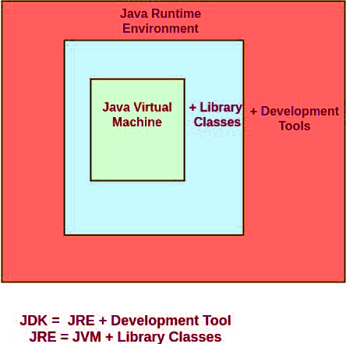

1. **What is JVM**

**Java Virtual Machine (JVM)** is a engine that provides runtime environment to drive the Java Code or applications. It converts Java bytecode into machines language. JVM is a part of Java Run Environment (JRE).

1. **Define Inheritance**

Inheritance can be defined as the process where one class acquires the properties (methods and fields) of another.

* The class which inherits the properties of other is known as subclass (derived class, child class) and the class whose properties are inherited is known as superclass (base class, parent class).

1. **How java achieved platform independence**

Every **Java** program runs on **Java** virtual machine, same byte code can be run on any **platform**. key is byte code is not machine instruction they are **platform independent** instruction to JVM. ... In summary combination of byte code and JVM makes **Java** program **platform independent**.

1. **Write the syntax of main function**

Public static void main(String args[]){

................................

...................................

..............................

}

1. **What is conditional operator**

The Java Conditional Operator selects one of two expressions for evaluation, which is based on the value of the first operands. It is also called **ternary operator**because it takes three arguments.

**Syntax**:

expression1 ? expression2:expression3;

1. **How many datatypes in java**

Data types are divided into two groups:

* Primitive data types - byte, short, int, long, float, double, boolean and char
* Non-primitive data types - such as [String](https://www.w3schools.com/java/java_strings.asp), [Arrays](https://www.w3schools.com/java/java_arrays.asp) and [Classes](https://www.w3schools.com/java/java_classes.asp)

**10)What is constant? How it is declared?**

The value which will not change in the memory are known as constants.

**Declaration:**

public static final int A = 0;